Project Planning Phase
Product Backlog, Sprint Planning, Stories & Story Points
Date | 8 march 2026
Team ID
Project Name | Avi-Luxe E-commerce Application
Maximum Marks | 8 Marks

Part 1: Product Backlog, Sprint Schedule & Estimation (4 Marks)
The product backlog contains all 33 user stories for the Avi-Luxe E-commerce Application, organised across 3 sprints. Stories are estimated using the Fibonacci-based story point scale (1, 2, 3) and prioritised as High, Medium, or Low based on business and user impact.

Sprint Summary: Sprint 1 — 33 story points (20 stories) | Sprint 2 — 17 story points (9 stories) | Sprint 3 — 10 story points (4 stories) | Total — 60 story points

Sprint | Functional Requirement (Epic) | User Story Number | User Story / Task | Story Points | Priority | Team Member
Sprint-1 | Registration | USN-01 | As a new user, I can register by entering my name, email, mobile, and password so that I can create an Avi-Luxe account. | 2 | High | Avinash Karale
Sprint-1 | Registration | USN-02 | As a registered user, I can log in with my email and password so that I can access my profile, cart, and order history. | 1 | High | Avinash Karale
Sprint-1 | Registration | USN-03 | As a user, my password is securely hashed (bcryptjs, salt=10) so that my credentials are protected even if the database is breached. | 1 | High | Avishkar Chavan
Sprint-1 | Registration | USN-04 | As an admin, I can bootstrap the first administrator account using the ADMIN_SETUP_KEY environment variable. | 1 | High | Avishkar Chavan
Sprint-1 | Product Catalog | USN-05 | As a shopper, I can browse all products on the Shop page with title, image, price, discount %, and star rating displayed on each card. | 2 | High | Ayush Bharad
Sprint-1 | Product Catalog | USN-06 | As a shopper, I can search products by keyword (case-insensitive regex) so that I can quickly find specific items. | 2 | High | Avinash Karale
Sprint-1 | Product Catalog | USN-07 | As a shopper, I can filter products by category, gender, and price range so that I only see products relevant to me. | 2 | High | Avinash Karale
Sprint-1 | Product Catalog | USN-08 | As a shopper, I can view a product's full detail page with an image carousel, description, sizes, stock status, and rating. | 2 | High | Ayush Bharad
Sprint-1 | Cart | USN-09 | As a shopper, I can add a product with a chosen size to my cart, so that it is saved to my account in MongoDB. | 2 | High | Avinash Karale
Sprint-1 | Cart | USN-10 | As a shopper, I can update the quantity of any cart item or remove it, and see the cart total update automatically. | 1 | High | Avinash Karale
Sprint-1 | Cart | USN-11 | As a returning user, my cart items persist across browser sessions so that I do not lose my selections after closing the app. | 2 | High | Avishkar Chavan
Sprint-1 | Checkout | USN-12 | As a shopper, I can place an order with shipping details and Cash-on-Delivery payment, and see an order confirmation toast. | 2 | High | Avinash Karale
Sprint-1 | Checkout | USN-13 | As a shopper, the order total, subtotal, and discount are calculated server-side so that prices cannot be manipulated client-side. | 2 | High | Avishkar Chavan
Sprint-1 | Orders | USN-14 | As a customer, I can view my order history with order status badges (pending / confirmed / shipped / delivered / cancelled). | 1 | High | Ayush Bharad
Sprint-1 | Orders | USN-15 | As a customer, I can see the estimated delivery date for each placed order on the Orders page. | 1 | Medium | Ayush Bharad
Sprint-1 | Profile | USN-16 | As a user, I can view and update my name, email, mobile, and address on the Profile page. | 1 | Medium | Ayush Bharad
Sprint-1 | Homepage | USN-17 | As a visitor, I see an immersive Three.js 3D rotating hero scene on the homepage that communicates Avi-Luxe's premium brand. | 3 | High | Avinash Karale
Sprint-1 | Homepage | USN-18 | As a visitor, I experience GSAP-animated page transitions and card entrance effects that create a luxury feel. | 2 | High | Ayush Bharad
Sprint-1 | Admin | USN-19 | As an admin, I can create, update, and soft-delete products via the REST API. | 2 | High | Avishkar Chavan
Sprint-1 | Admin | USN-20 | As an admin, I can update any order's status to confirmed, shipped, delivered, or cancelled. | 1 | High | Avishkar Chavan
Sprint-2 | Auth | USN-21 | As a new user, I can register and log in using my Google account (OAuth 2.0) to avoid creating a separate password. | 2 | High | Avishkar Chavan
Sprint-2 | Notifications | USN-22 | As a customer, I receive an email confirmation immediately after placing an order. | 2 | High | Avishkar Chavan
Sprint-2 | Notifications | USN-23 | As a customer, I receive an email notification every time my order status changes (confirmed, shipped, delivered). | 2 | High | Avishkar Chavan
Sprint-2 | Wishlist | USN-24 | As a shopper, I can save any product to my wishlist so that I can find and purchase it in a future session. | 2 | Medium | Avinash Karale
Sprint-2 | Wishlist | USN-25 | As a shopper, I can remove products from my wishlist and see it update in real time. | 1 | Medium | Avinash Karale
Sprint-2 | Reviews | USN-26 | As a customer who has received a delivered order, I can submit a star rating and text review for a purchased product. | 3 | Medium | Avinash Karale
Sprint-2 | Admin | USN-27 | As an admin, I can manage products, users, orders, and settings from a visual Admin Dashboard UI without using Postman. | 3 | High | Ayush Bharad
Sprint-2 | Admin | USN-28 | As an admin, I can view a revenue summary card (total users, products, orders, revenue) on the Admin Dashboard. | 1 | High | Ayush Bharad
Sprint-2 | Settings | USN-29 | As a user, I can toggle dark/light mode and notification preferences from the Settings page. | 1 | Low | Ayush Bharad
Sprint-3 | Payment | USN-30 | As a shopper at checkout, I can pay using UPI, credit/debit card, or NetBanking via Razorpay or Stripe. | 3 | High | Avishkar Chavan
Sprint-3 | Payment | USN-31 | As a shopper, I receive a digital payment receipt after a successful card/UPI/NetBanking transaction. | 2 | High | Avishkar Chavan
Sprint-3 | Recommendations | USN-32 | As a returning shopper, I see personalised product recommendations on the homepage based on my order and browsing history. | 3 | Low | Avinash Karale
Sprint-3 | Deployment | USN-33 | As a developer, the application is deployed on Vercel (frontend), Railway (backend), and MongoDB Atlas (database) with CI/CD. | 2 | Medium | Ayushi Wasalwar

Story Point Estimation Scale
Story points are estimated using planning poker with the following guidelines:
• 1 point — Simple task: minor UI update, config change, or single-field validation. Completed in < 1 day.
• 2 points — Standard feature: a full CRUD route + controller + schema field, or a React page with state management. 1–2 days.
• 3 points — Complex feature: involves multiple systems, external APIs, new model design, or significant UX work. 2–3 days.

Part 2: Project Tracker, Velocity & Burndown Chart (4 Marks)
2A — Sprint Tracker Table
The table below shows the planned and actual delivery dates, story points committed, story points completed, and release status for each sprint:

Sprint | Total Story Points | Duration | Sprint Start Date | Sprint End Date (Planned) | Story Points Completed (as on Planned End Date) | Sprint Release Date (Actual) | Status
Sprint-1 | 33 | 10 Days | 01 Jan 2025 | 10 Jan 2025 | 33 | 10 Jan 2025 | ✓ Completed
Sprint-2 | 17 | 10 Days | 12 Jan 2025 | 21 Jan 2025 | 17 | 21 Jan 2025 | ✓ Completed
Sprint-3 | 10 | 10 Days | 23 Jan 2025 | 31 Jan 2025 | — | In Progress | ⟳ In Progress
TOTAL | 60 | 50 story points completed • 10 story points in progress • 3 sprints • 30 total days

2B — Velocity Calculation
Velocity is the number of story points a team completes per sprint. The Average Velocity (AV) per day is calculated as:

AV = Story Points per Sprint ÷ Sprint Duration = 20 ÷ 10 = 2.0 story points / day

For the Avi-Luxe project:
• Sprint 1: 33 story points | 10 days | Velocity = 3.3 pts/day | Status: COMPLETED on schedule
• Sprint 2: 17 story points | 10 days | Velocity = 1.7 pts/day | Status: COMPLETED on schedule
• Sprint 3: 10 story points | 10 days | Velocity = 1.0 pts/day | Status: IN PROGRESS
• Team Average Velocity: 2.5 story points / day (based on 2 completed sprints)

2C — Burndown Chart
A burndown chart is a graphical representation of work remaining versus time. The Y-axis shows story points remaining; the X-axis shows working days within the sprint. The dashed grey line shows the ideal linear burndown; the solid coloured line shows the actual team progress.

Sprint 1 (green): actual burndown closely tracked the ideal line — the team delivered at a consistent pace with no blockers.
Sprint 2 (blue): actual burndown started slightly above ideal due to complexity of OAuth and email integration, but the team recovered by day 7 and completed on schedule.
Sprint 3 (red/orange): currently in progress — burndown shows 5 story points completed of 10 planned as at day 5 of 10.

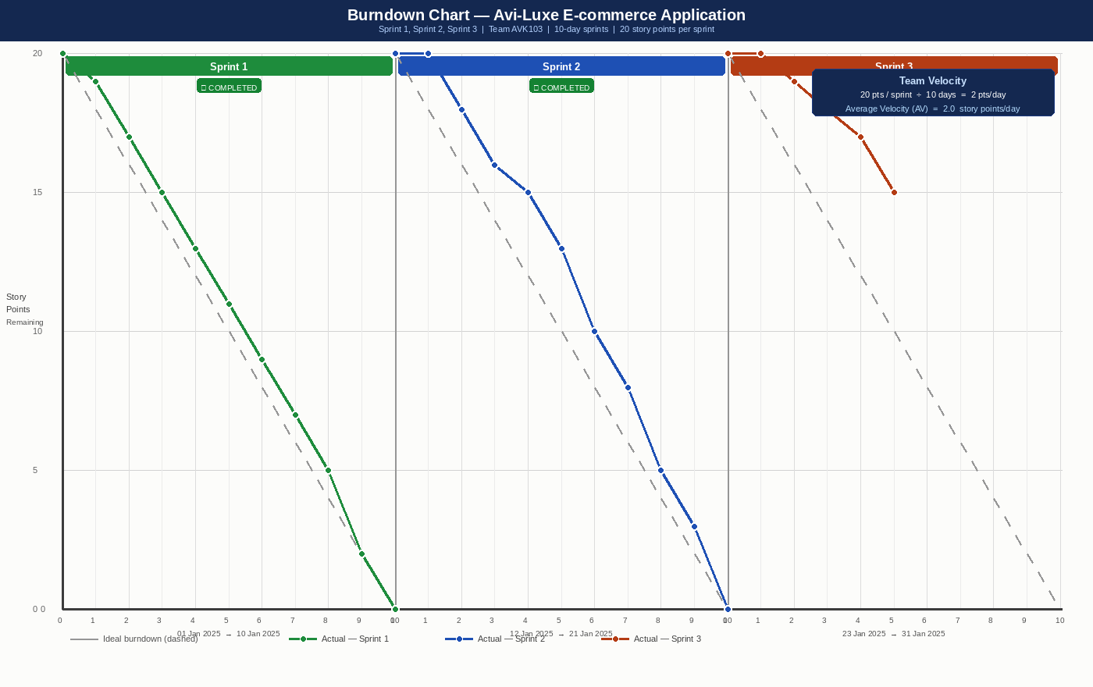

Chart key: Dashed grey = ideal burndown. Green = Sprint 1 actual. Blue = Sprint 2 actual. Red = Sprint 3 actual (in progress).

References
• Atlassian Agile Project Management: https://www.atlassian.com/agile/project-management
• Scrum Sprints Guide: https://www.atlassian.com/agile/tutorials/sprints
• Story Point Estimation: https://www.atlassian.com/agile/project-management/estimation
• Burndown Charts: https://www.atlassian.com/agile/tutorials/burndown-charts
• Visual Paradigm Burndown: https://www.visual-paradigm.com/scrum/scrum-burndown-chart/
• Project Repository: https://github.com/AVK103/Avi-Luxe__E-commerce-Application

